**NEW CAESAR**

Decided to write code to make the program run in reverse.

Stored the value in the question variable enc and as the key

could have been any character from a to p, I decided to

create a list named b16 so, that I can convert the encryption

for all possible keys.

Reversing the function shift :

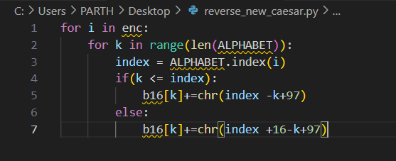

I looped through each value of enc and converted it for each possible key. We know that the index of i in ALPHABET needs to equal the character we are looking - 97 and the key -97 modulus 16.

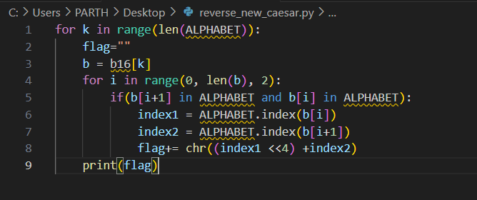

FLAG :

picoCTF{et_tu?_1ac5f3d7920a85610afeb2572831daa8}